Whispers from the Wilds

Macintosh HD:Users:narciss:Desktop:000 DND_ASSETS:DnD SHARDS:DnD_shard.eps

By Malcolm Sinclair

|  |
| --- |
| Avarus |
|  |



Credits

Blue Spruce Softworks

**Designer:** Malcolm Sinclair

**Editor:** TBD

**Illustrator:** TBD

**Cartographer:** Malcolm Sinclair

Foreword

The following text is the work of Malcolm Sinclair, a storyteller and world builder. Coming late to the DMing scene, I immediately fell in love with the freedom, and fun that Dungeons & Dragons offered. Being a storyteller myself, I had greatly desired to throw my hat into the ring of these amazing worlds explored, and the amazing stories told in them. Though it wouldn’t be until now, that I did.

This campaign, and the world of Avarus has been by proverbial baby for a long time. Everything from the geography to the history, its inhabitants and everything that holds them together, has been poured over, and carefully crafted, and re-worked more times than I care to admit. But I hope you can take this work and make it yours. Explore the world of Avarus on your own account. Blaze your own paths and forge your own tales, in its rugged peaks and dreary forests. I suppose all that is left to say is: happy trails!

Malcolm Sinclair

June 2024

This is where the cover art, with the author and a brief description, will go.

Table of Contents

*Map*: Westavar **4**

Introduction**5**

Background**5**

Overview**5**

Episode 1: Festival in Flames6

The Festival6

Appendix A: Extra Mechanicsx

Appendix B: Magic Itemsx

Appendix C: Monstersx

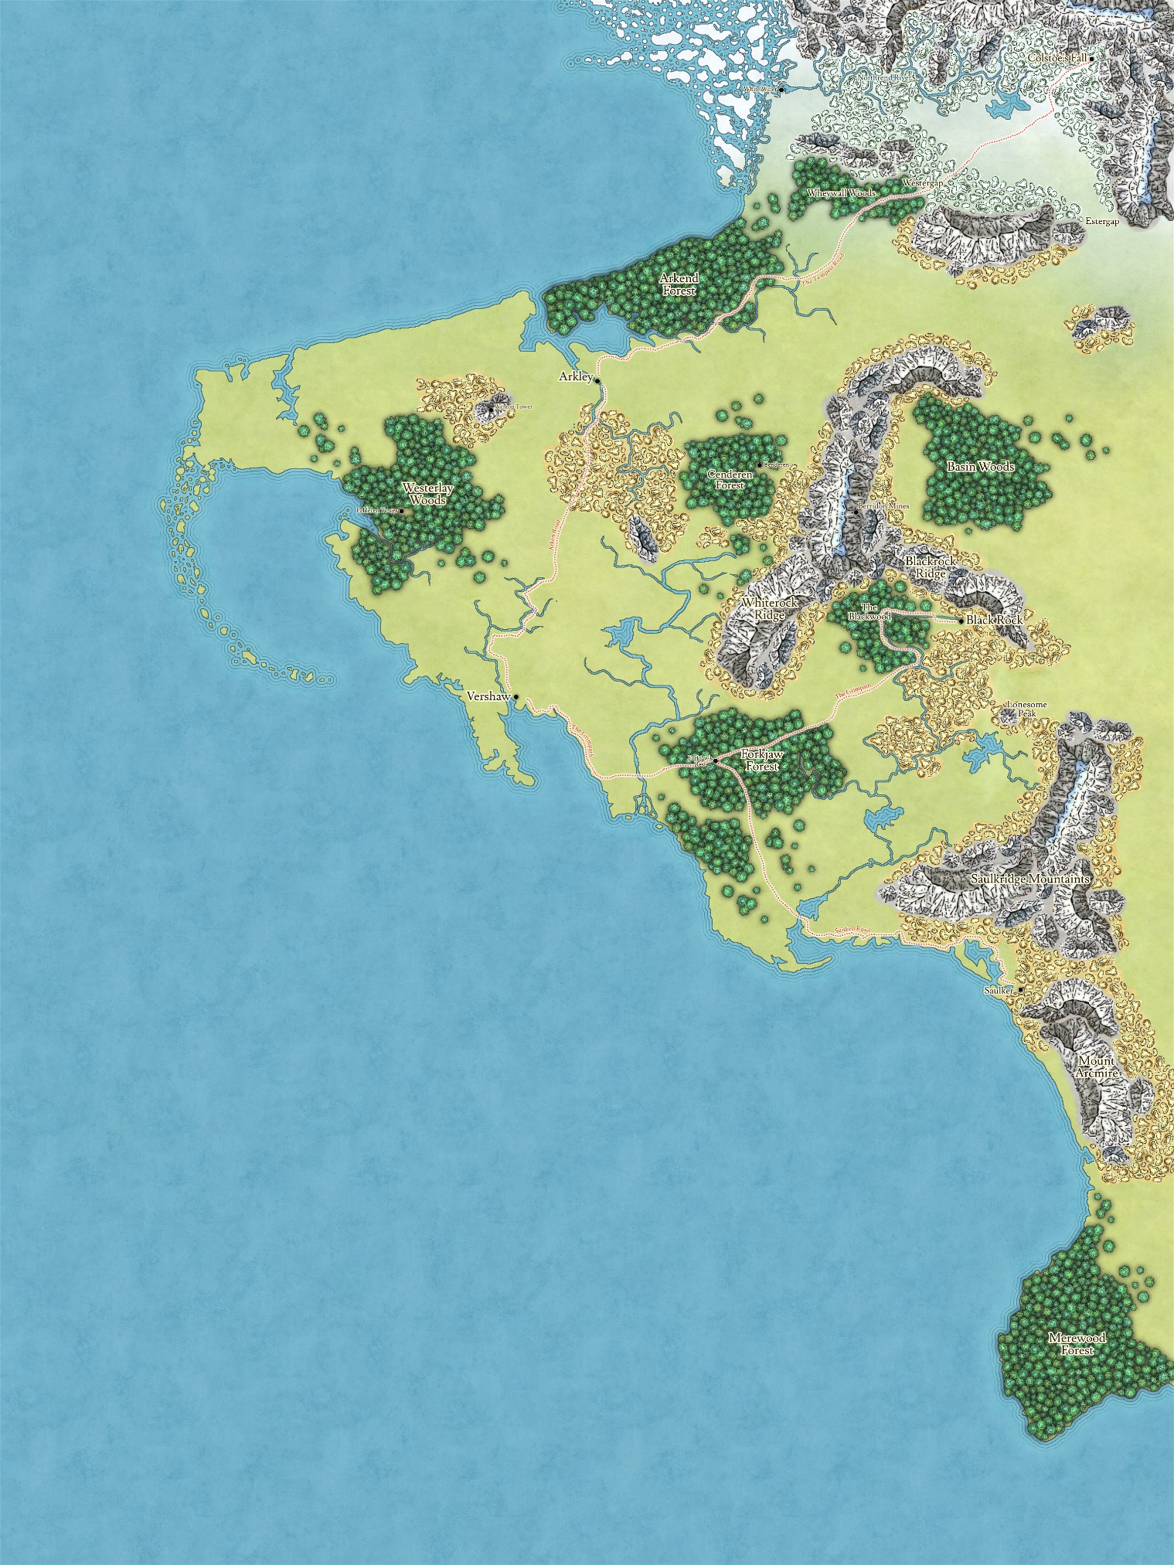

Introduction

W

hispers from the Wilds is the inaugural campaign of Avarus. More specifically, the west coast of the continent of Avarus, known as the Westavar. The adventure you are about to embark upon is expansive and will take a party of four players from level 1 to around level 15 or 16, depending on the amount of extra-campaign content they chose to explore (of which there is plenty).

This campaign takes place primarily on the stretch of coast, starting in the small fishing town of Saulker, to the large mountain-bound city of Colstoe’s Fall in the north, with heavy emphasis on the cities of Vershaw, and Arkley; the two primary powers in this stretch of the continent.

***Character Advancement.*** Whispers from the Wilds is intended to be played using XP advancement, however milestone advancement is also an option. In which case, players can be granted a level after completing each episode of the campaign.

Background

After a devastating conflict between Versaw and Arkley nearly 200 years ago, and the ensuing armistice, Westavar has seen an era of uneasy peace. In which time, both cities made their own efforts to expand and colonize the rest of the region. Vershaw sent campaigns south and east, Arkley making their own moves toward the north. Even still, much of the land goes untamed.

Rumors

However, worrisome stories have begun to brew in the south. Tales of strange creatures, of twisted bark, and abominations born of earth, attacking hamlets and farmsteads, killing and razing everything they come across.

These rumors have been widely ignored thus far, being taken as mere embellishments of routine goblin, kobold, or bandit attacks. But the tales and rumors persist and have slowly been spreading north and west. Many in the path of these rumored creatures have begun to worry about their safety, some small hamlets and other communities doing their best to raise small militias, should their home be the next target. But Saulker, the town closest to the epicenter of these rumors has yet to act.

The Source

The source of these rumors is only speculation to the people of Westavar, but as the DM, you get the inside scoop.

Beyond the material plane, Silvanus: Greenfather, and the god of wild nature has become disillusioned with humanity and bent on its utter destruction. Warping the earth and its creatures into vile abominations with the sole purpose of burning the human scourge from the earth, so that he may reseed, and grow the earth anew. To oversee this task, he has entrusted his most devout follower, an Elf man named Ayrin’Jae, to lead the effort.

Unbeknownst to Ayrin—however, is that the mind of his beloved patron has been poisoned and twisted, by one who lurks in the shadows, a powerful mechanist known only as the Iron Crow, with plans of his own, and dreams above his station.

The Iron Crow

More about the Iron Crow will arise in subsequent episodes, as his influence becomes more relevant. For now, a brief overview of the mark of the Iron Crow on Westavar will suffice.

Throughout the region, small groups of people, who claim to worship the Iron Crow have been arising. Predominantly in a guild known as the Fist of the Crow, stationed in Black Rock. Not much is known about the guild, or their religious practices to outsiders. But within their ranks, they have been preparing for the colonization of currently uninhabited land in the eastern Basin Woods, where a strange, abandoned pyramid stands. Formerly the headquarters of the Arc Emergents, a group of arcane scholars, who seemingly vanished 100 years ago.

Overview

Over the course of this adventure, the Fist of the Crow, and the forces of Ayrin’Jae will advance on Westavar, both furthering their own plots, that will increasingly intermingle throughout the campaign.

The story begins when the annual Saulker Fish Festival is cut short, by a brutal and devastating attack on the town, by the abominations of Ayrin’Jae. The efforts of the party to avenge their home lead them on a search for the scourge, and its source. Eventually, they discover the camp of Ayrin’Jae, and after a brutal battle, with the help of a keen stranger, named Everett Reed, they manage to learn about the wrath of Silvanus.

Everett guides them, with or without the help of the Fist of the Crow, they ensnare Silvanus, preventing him from enacting any further destruction. Then, with the pyramid fully converted, the Fist of the Crow traps the party, and begins to drain Silvanus of his life, channeling it to their lord: the Iron Crow.

With a new villain on their radar, the party sets out to destroy the pyramid, and with it, the Iron Crow, and his Fist.

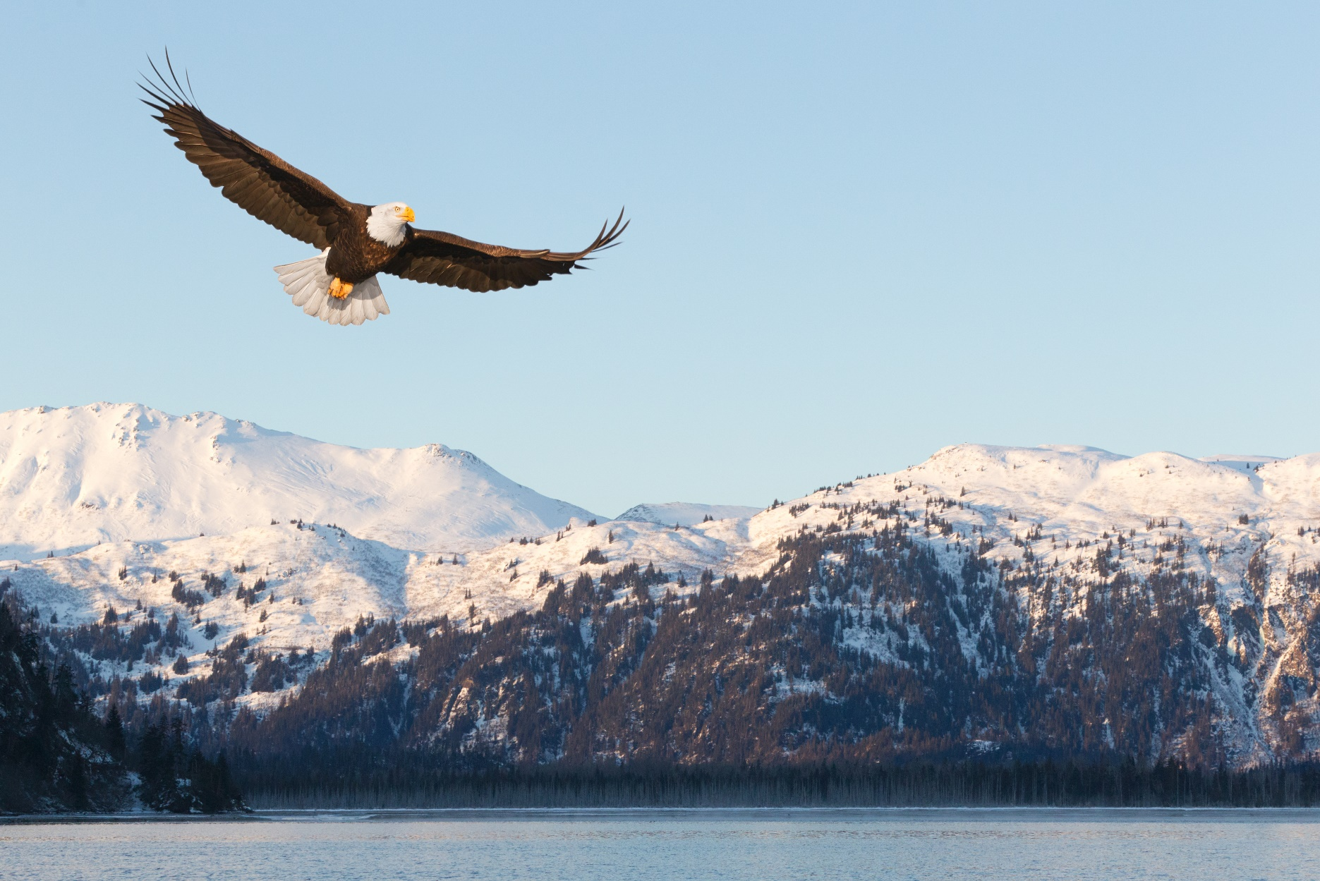Episode 1: Festival in Flames

Saulker was founded around 80 years ago. When the city of Vershaw started a development campaign, incentivizing settlers to travel to uninhabited places, and make them their own. In this endeavor, 3 families united in the founding of Saulker: the Abbots, the Canis’ and the Mauredars.

The Abbots have come to be the trusted leaders of the village. While Saulker has democratic elections, many of the elected barons throughout the village’s lifetime have been an Abbot. Baron Reymon Abbot being the most recent of these.

The Canis family have been much less outspoken in the town’s leadership. They had taken to a darker side, establishing a new branch of the Watchers of the Moon thief’s guild, in the south. More information on the Watchers of the Moon can be found in later chapters.

The Mauredar family seemingly vanished nearly 50 years ago. Little more information is known to the common person. To those who know, the Mauredar family went east and north, establishing a keep there. Then began delving into the occult. The Mauredar family will be explained in more detail in later episodes.

The Festival

The Saulker fish festival was created by Barron Rory Abbot 50 years ago. Meaning this year is a very special festival, as it’s the event’s 50th anniversary. Barron Reymon Abbot has spared no expense in its preparation.

When you are ready to begin, read the following aloud.

For the past few days, the town of Saulker has been abuzz with excitement for the coming festival. And now, moments before the opening, you begin to feel I too. The smell of freshly baked goods, mingled with the salt of the sea; the sound of lapping waves, chirping gulls, and merchants selling their goods.

There are various activities that players can partake in. A few of these activities are not explained in detail, but rules and specifics can be found in Appendix A.

Throne

Throne is a card game that can be played with a standard deck of 52 cards. Each player receives one suit. This means that the player count can be between 2 and 4, unless you have multiple decks of visually distinct cart. In which case you can have as many players as you have distinctive suits. Instructions on how to play can be found in Appendix A.

The Throne stall is run by an older woman named Gaela, a short, hunched woman, with long matted grey hair. For the past nearly 4 decades, has been the secretary of the Trawler Houses’ headquarters, and when not on the job, can be found frequently playing games of Throne in the Coppermug inn and tavern.

Hog Riding